AGENTIC AI DAILY WORK
Day 1:
LLM API call
API key = Username + Password + Billing Identity
Import SDK
↓
Configure API Key
↓
Create Model Object
↓
Send Prompt
↓
Gemini API Server
↓
Generate Response
↓
Receive Response Object
↓
Extract response.text
↓
Print Output
What happens when you call generate_content()?
- The prompt is packaged by the SDK.
- The API key is attached for authentication.
- An HTTPS request is sent to Gemini servers.
- Gemini processes the prompt using the selected model.
- The generated response is returned as a response object.
- We access the generated text using response.text.

Task | Tool
Learn prompting | Google AI Studio
Learn API calls | Gemini Free Tier
Build agents | Ollama + Llama 3
Learn LangGraph/CrewAI | Local models first
Portfolio projects | Gemini API or OpenAI API

PART 1- AI Concepts
Artificial Intelligence- It is a branch of Computer Science that aims to build systems that are capable of performing tasks that usually require human intelligence like learning, reasoning, understanding languages, image recognition and making decisions.

Machine Learning- It is a subset of AI, where algorithms learn patterns from data instead of being explicitly programmed.

Deep learning- It is a subset of ML that uses Neural Networks with multiple layers to solve complex problems.

Neural Network- It is a computational model inspired by the human brain that learns the patterns by connecting multiple layers of artificial neurons.

Transformer- It is a deep learning architecture that uses attention mechanism to process all the words in parallel and understand the relationship between them, making it highly effective for natural language processing.
Before transformer the model uses to process word by word sequentially.

Large Language Model – LLM are large DL model that are trained on huge amount of data. They don't think like humans. They predict the most likely next token based on patterns learned during training. LLMs are the underlying engine.

Generative Pre-trained Transformer- GPT is a specific family of LLMs developed by OpenAI. It is one specific type of engine among many. An LLM is the general category, while GPT is one specific brand or family within that category. Every GPT is an LLM, but not every LLM is a GPT.

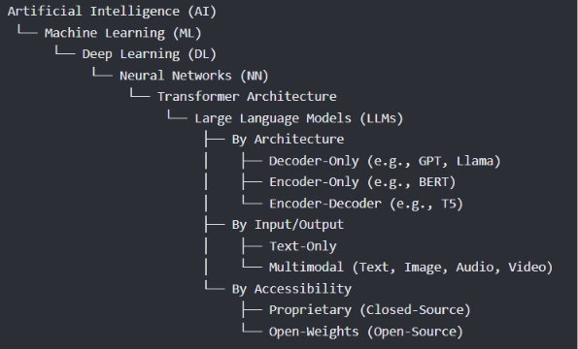
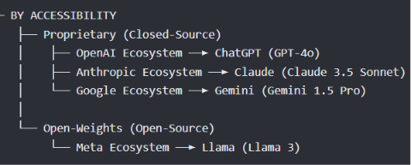

Tokens- pieces of text that a language model uses to read, process, and generate information.
100 tokens ≈ 75 words
1 token ≈ 4 characters
Tokens matters:
- APIs charge per token.
- Context window is measured in tokens.
- Responses are limited by tokens.
Context window- is the maximum amount of text—measured in tokens—that a Large Language Model (LLM) can process and "remember" at one time.

Temperature- a parameter that controls the randomness and creativity of the generated text. It adjusts how the model selects the next word: a low temperature makes the output focused and predictable, while a high temperature encourages diverse and creative responses.
- Low Temperature (e.g., 0.0 - 0.3): This sharpens the probability distribution. The model heavily favors the most highly probable word. The output becomes highly focused, factual, and deterministic (repeating the same prompt will yield the same answer).
- Medium Temperature (e.g., 0.4 - 0.7): This offers a balanced approach. It allows the model to select varied words while staying firmly on track with the context and intent of the prompt.
- High Temperature (e.g., 0.8 - 1.0+): This flattens the probability distribution. Words that were initially deemed less likely suddenly get a much higher chance of being picked. The text becomes highly creative, diverse, and sometimes unpredictable.
Setting | Temperature Value | Best Use Case
Deterministic | 0.0 to 0.2 | Data extraction, coding, math problems, translating, or summarizing factual documents.
Balanced | 0.3 to 0.7 | Standard assistant tasks, general research, Q&A, and professional writing.
Creative | 0.8 to 1.2+ | Brainstorming ideas, writing fiction, poetry, or generating open-ended dialogue.

Embeddings- a numerical representation of text where words or concepts with similar meanings are mapped to vectors that are close to each other in a multi-dimensional space. It acts as a "meaning map" that translates human language into a language machines can process mathematically.
Words with similar meanings (e.g., "cat" and "kitten") will sit right next to each other.
Words with opposite concepts (e.g., "hot" and "cold") are placed further apart.

PART 2- Python basics
* Functions
* Classes and Objects
* Lists
* Dictionaries
* Loops
* Exception Handling (try / except)
* Reading and writing JSON
* Modules and imports
* Creating and activating a virtual environment (venv)
* Installing packages with pip

PART 3 - Development Environment Setup
- Create the Project Structure
Folder/File | Purpose
.venv | Virtual Environment
.env | Store API keys securely
.gitignore | Ignore files that shouldn't go to GitHub
README.md | Project documentation
requirements.txt | List of installed Python packages

- Create a Virtual Environment
python -m venv .venv
- python → Run Python.
- -m → Run a Python module.
- venv → Virtual environment module.
- .venv → Name of the environment folder.

- Activate the Virtual Environment
.\.venv\Scripts\Activate.ps1

- Deactivate the Virtual Environment
Deactivate

- Upgrade pip
python -m pip install --upgrade pip

- Install Required Packages
pip install google-genai python-dotenv
- google-genai → Gemini API SDK.
- python-dotenv → Reads API keys from .env.

- Save Installed Packages
pip freeze > requirements.txt

- Create .env
GEMINI_API_KEY=your_api_key_here

- Create .gitignore
# Virtual Environment
.venv/
venv/
# Environment Variables
.env
# Python Cache
__pycache__/
*.pyc
# VS Code Settings
.vscode/
# OS Files
.DS_Store
Thumbs.db

- Creates a Git repository.
git init

- Rename Default Branch
git branch -M main

- Check Git Status
git status

- Test API key

PART 4- Gemini Chatbot
Line | Purpose
from google import genai | Import Gemini SDK
load_dotenv() | Load .env variables
os.getenv() | Read the API key
genai.Client() | Create a connection to Gemini
generate_content() | Send a prompt
response.text | Get Gemini's answer

Types of Prompts
There are three common types you'll encounter.
1. Simple Prompt
What is SQL?
The model answers, but its style isn't guided.

2. Role-Based Prompt
You are an experienced Data Analyst.
Explain SQL in beginner-friendly language.
Now the model has a role.

3. Structured Prompt
You are a senior Data Analyst.
Whenever you answer:
- Explain in simple language.
- Give a real-world example.
- Mention common interview questions.
- End with one practical tip.
This usually produces much better responses.

